MCJA September 23, 2022 Business Meeting Minutes
- Welcome and Call to Order - Dena Carson at 4pm
  - Turnout is inspiring
  - Rooms filled
- Dena showed representation of Exec Board
- Updates
  - At Hilton Garden Inn for 5 years and have enjoyed time at the hotel, but we are at a point now to shop for another hotel contract or comparable location
    - Need volunteers for Location Planning Committee 2022-23
  - Made changes to the program schedule this year - went really well moving keynote to Thursday instead of Friday
  - Projectors are dim so Dena will be working to get new ones
  - Matt Matusiak has switched us entirely over to Google Gmail to help offset emails we sent from going to junk mail folders.
  - For Midyear meeting minutes, go to MCJA’s website
- Heather Pfeifer - ACJS Immediate Past President
  - Impressed with MCJA so much and will be referring lots of students here
  - Meeting at National Harbor Gaylord Resort and Convention Center
    - 60th year of ACJS
    - Denise Boots has put together an excellent program on civil rights and social justice with activities, events, and keynote aligned strongly with the theme
    - Teaching workshops and others on Tuesday
    - Full day on mental health programming for faculty, QPR training
    - ACJS piloting a mentoring initiative
      - Survey going out in a couple weeks to see who wants to be mentored followed by a second survey as to whom would like to be mentored
      - Kickoff meeting in National Harbor
- Treasurer’s Report
  - 2021-22 ended with 116 members
    - Big increase for us
    - 32 student members in that number
    - 73 members for 2022-23 as of 9/19/22, up from last year when we just had 50
    - Conference
      - 107 total pre-registrants with 21 onsite
      - 13 student posters - has to be a record for us
      - Showed Square transactions - 169 as of 2 weeks ago
      - As of 9/13/22 - Cash assets are about $81,000 and our outlays were $22,000, which includes conference, award money, journal
      - In 2020, we didn’t have the face-to-face conference, but the virtual one put together by Bree garnered a lot of sponsors so now we are flush with money
        - Thinking of putting some money in savings account to help support student travel and also having an option for people to donate to this fund
        - Are we going to name the scholarships after the members who have passed has been a conversation - honoring Mike Leiber and Mitch Chamlin - and brought up for discussion
        - Natalie questioned if there was a woman who can be named or if we had a rotating named-scholarship annually
        - Justin suggested we could have an “MCJA Memorial Scholarship” and list the individuals we have In honor
        - Natalie - Should we hire a financial analyst/planner to see how we can invest the money in something other than a savings account? Still want to be able to draw from the fund.
        - Natalie also asked if we wanted to have a committee. Bob Hanson suggested bringing back Ideas to the ACJS meeting by members reaching out to those who know about financials.
          - Dena will talk with AJ and get his thoughts
- Journal report - George Burruss
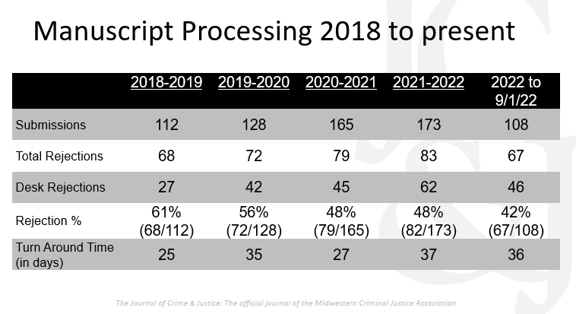
  - Big concern has been how long the turnaround time has been with reviewers - perhaps due to the pandemic
    - Trying to find ways to deliver quick turnaround and objective review as Mike Leiber originally intended
  - Impact factor score - In line with other journals tiered similarly
    - Ranking dropped, however
      - Previous IF: 2.080 (inflated after recalibration)
      - 2021 IF: 1.292
      - Five-year IF: 1.660
      - From 43rd to 56th place of 69 in Criminology & Penology
    - How to increase our place in the field - Ideas for more exposure
      - Publisher suggested reaching out to International scholars and attending their conferences
      - President from MCJA looks through abstract of the conference and puts together a request for articles for selection to peer review articles
      - Invited essays from scholars on crime and justice
  - Special journal issues forthcoming
    - Jen Peck & Maude Beaudry-Cyr: Striving for Equality in the Juvenile Court and Juvenile Delinquency: Empirical Studies in Honor of Michael J. Leiber (2022)
    - Joseph Schafer, Julie Hibdon, Michael Kyle: Measurement and Methodology: Addressing Challenges and Exploring Opportunities (2023)
    - Chae Jaynes: Employment and rational choice (2024).
    - Benoit Dupont, Rutger Leukfeldt, Francis Fortin: Empirical Research on Cybercrime (2025)
    - If you have an idea for a topic for a special issue for 2026 and beyond, talk with George
    - Natalie Kroovand Hipple suggested research in the Midwest as a special issue like what was done here at MCJA conference
  - Outstanding Paper Award Recipient for Paper Published in 2021
    - Robert M. Adelman, Yulin Yang, Lesley Williams Reid, James D. Bachmeier & Mike Maciag: Using estimates of undocumented immigrants to study the immigration-crime relationship. Issue: 43 (2)
    - Judges: Matthew Giblin, Joseph Ferrandino, Brandon Kooi
  - George’s last year as editor and there will be a call coming out in spring 2023
- Awards
  - No practitioner award this year
  - Tom Castellano Award
    - Breanne Pleggenkuhle, Southern Illinois University – Dena shared that Breanne has given up a lot for the organization and was president during the pandemic. She went above and beyond to keep MCJA going during that tough time. She brings students, continues to support MCJA through website and many other ways
  - Outstanding MCJA Graduate Paper Award
    - Jayden Richards, University of Wisconsin – A Spatial Analysis of Homicides in Milwaukee, Wisconsin
  - Graduate Student Poster Award
    - Alejandro Cervantes, Kenneth Novak, University of Missouri-Kansas City: Examining Fatal and Non-Fatal Gun Violence in Kansas City
    - Honorable Mention - Alexis Sir Louis, Chloe Wentzlof, Philip Stinson, Bowling Green State University: Driving While Female: An Exploratory Study Examining Law Enforcement’s Abuse of Power Against Female Drivers, 2005-2017
  - Undergraduate Student Paper Award
    - Danielle LaPradd, Southern Illinois University: Gender Disparity and Sentencing Severity: The Role of Gender in Criminal Sentencing
  - UG Student Poster Award
    - Kayla Hauser, Hannah Snoke, Kevin Spade, Kaitlin McClintick, Catherine Pape (advisor), Melissa Burek (advisor), Bowling Green State University: Pressure Pushing Down on Me: Finding an Internship Placement
    - Karlee Augustus, Madeline Loso, Jonathan Ralston, Joshua Lawless, Melissa Burek (advisor), Catherine Pape (advisor), Bowling Green State University: Required Internships for Criminal Justice Degree Attainment: Now I’m Stressed Out
    - Honorable Mention – Steve Nelson, Valerie Bell: Disabled, Homosexual, or Nonbinary: Are You are a More Likely Target for Bullying in School?
  - Dena thanked the paper and poster competition judges
  - Dena encouraged people to serve as a judge or chair the student paper and poster competitions
  - Note that we also have the Practitioner Award that was not awarded this year
  - Contact Dena or any other Board member to learn more about the awards
- Moving Forward
  - Summer Elections for 2nd VP, Treasurer, Secretary so plenty of opportunities to support MCJA in the upcoming year
  - Doing editor search as well for Journal of Crime and Justice
  - 2022-23 – Elected 2nd VP is Catherine Pape from Bowling Green State University- Dena noted that we can’t be more excited that she is going to be on the board
  - Sponsorships from Midwestern CJ universities and organizations thanked
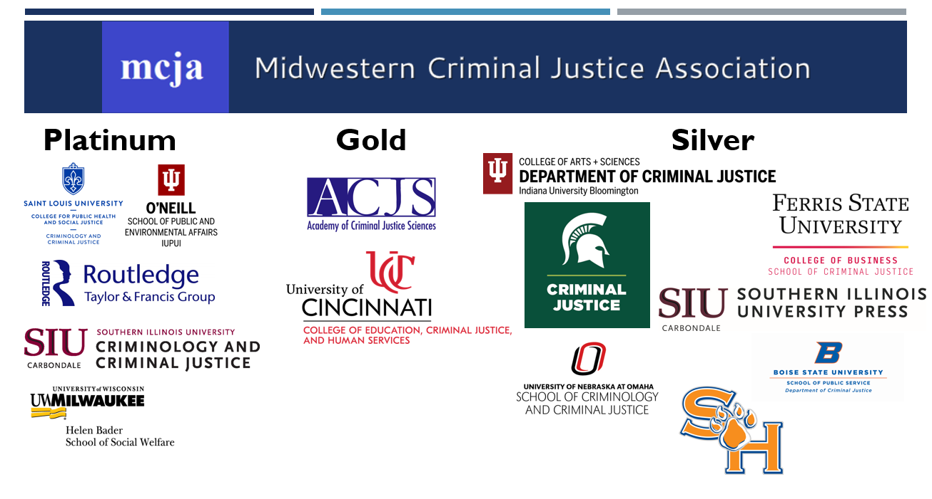
  - Cory Haberman is now president - Dena passed the pen
  - Meeting adjourned 4:46pm

