Midwestern Criminal Justice Association
Examining Criminal Justice and Criminology Through the Lens of Intersectionality
42st Annual Meeting

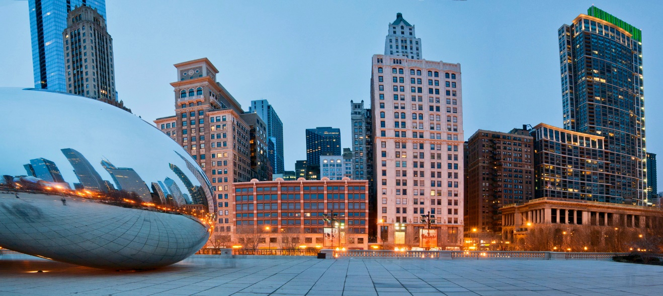

Chicago, Illinois
Thursday, September 26th – Friday, September 27th, 2019

CALL FOR PRESENTATIONS
Abstract Submission Deadline: August 1, 2019
Submit online at http://www.mcja.org/abstract-submission.html

President
Kiesha Warren-Gordon, Ph.D
Ball State University
kwarrengordo@bsu.edu

1st Vice President & Program Chair
Breanne Pleggenkuhle
Southern Illinois University Carbondale
bpleggenkuhle@siu.edu

Conference Hotel
Hilton Garden Inn Chicago
Downtown/Magnificent Mile
10 E. Grand Avenue
Chicago, IL 60611
Just minutes away from the Magnificent Mile!

Online Hotel Reservations: http://www.mcja.org/annual-meeting.html
(800) 445-8667 (must mention MCJA when booking through telephone)
Reservations must be made by August 31, 2018 to confirm conference rate

For more information about the annual meeting, abstract submission, hotel reservations, sponsorships, the STUDENT PAPER COMPETITION, and other ways you can participate, visit us at:

www.mcja.org

